**Work Experience codes:**

Java code to parse xml using dom

<https://mkyong.com/java/how-to-read-xml-file-in-java-dom-parser/>

sax

<https://mkyong.com/java/how-to-read-xml-file-in-java-sax-parser/>

JAXB

<https://www.javatpoint.com/jaxb-unmarshalling-example>

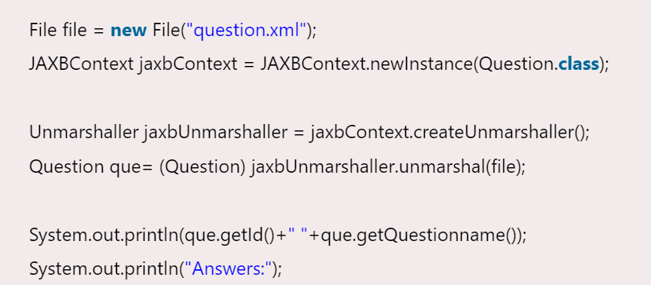

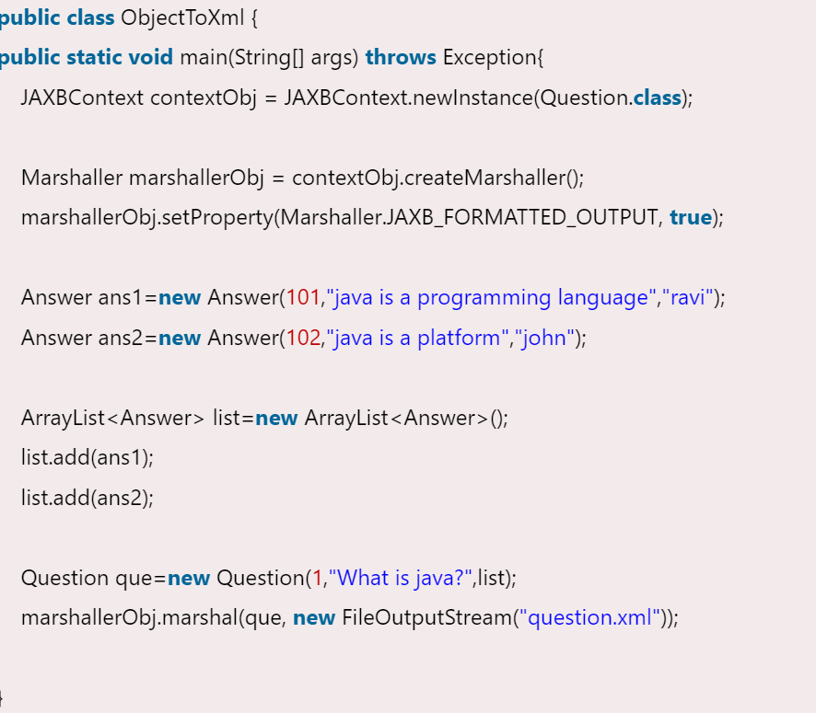

XSLT

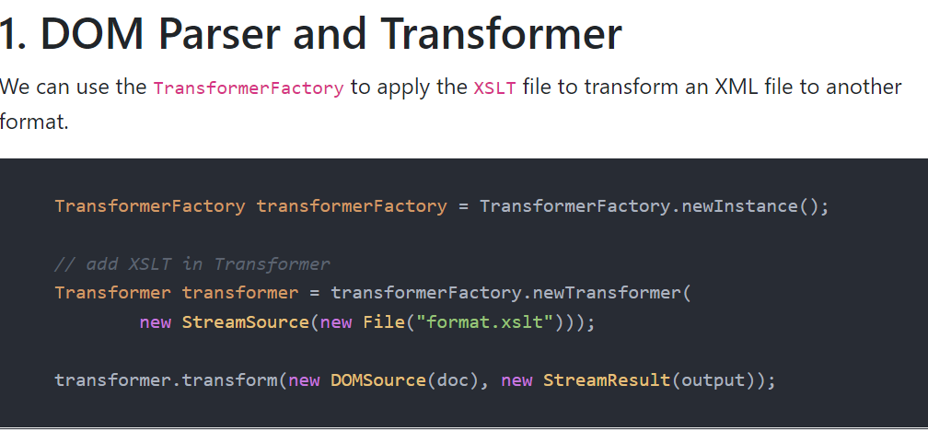

<https://mkyong.com/java/java-dom-parser-xml-and-xslt-examples/>

PDF Itext

<https://www.codeproject.com/Tips/679606/Filling-PDF-Form-using-iText-PDF-Library>

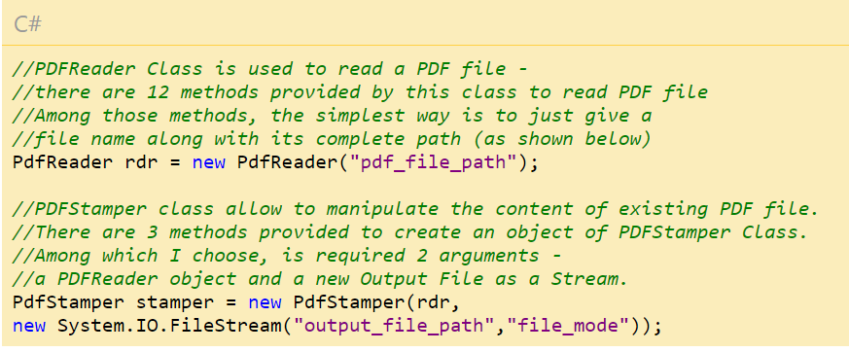

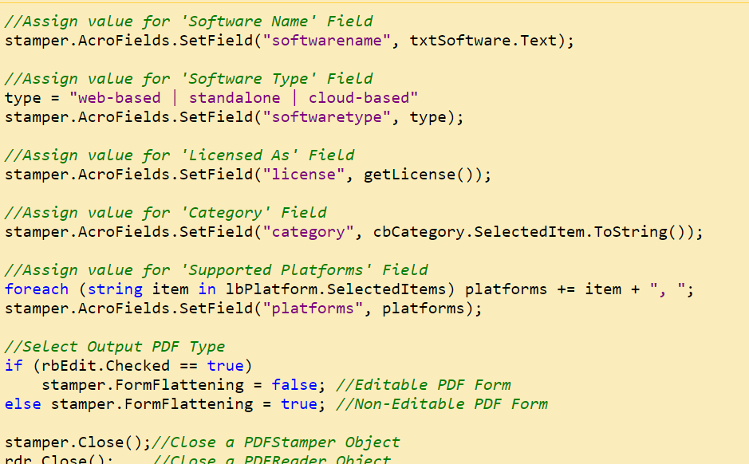

SFTP:

<https://www.javatpoint.com/java-sftp>

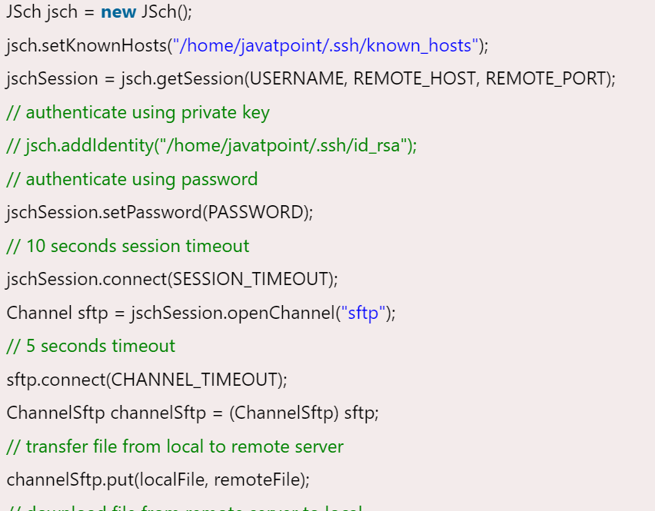

SAAJ

<https://stackoverflow.com/questions/15948927/working-soap-client-example>

HTTPUrlCoonection

<https://www.geeksforgeeks.org/java-net-httpurlconnection-class-java/>